Applications Year 12 Investigation 1 2018
Pre Task Activities

- Investigate the relationships between the
Temperature at 9 am and
- the temperature at 3pm
- The maximum daily temperature
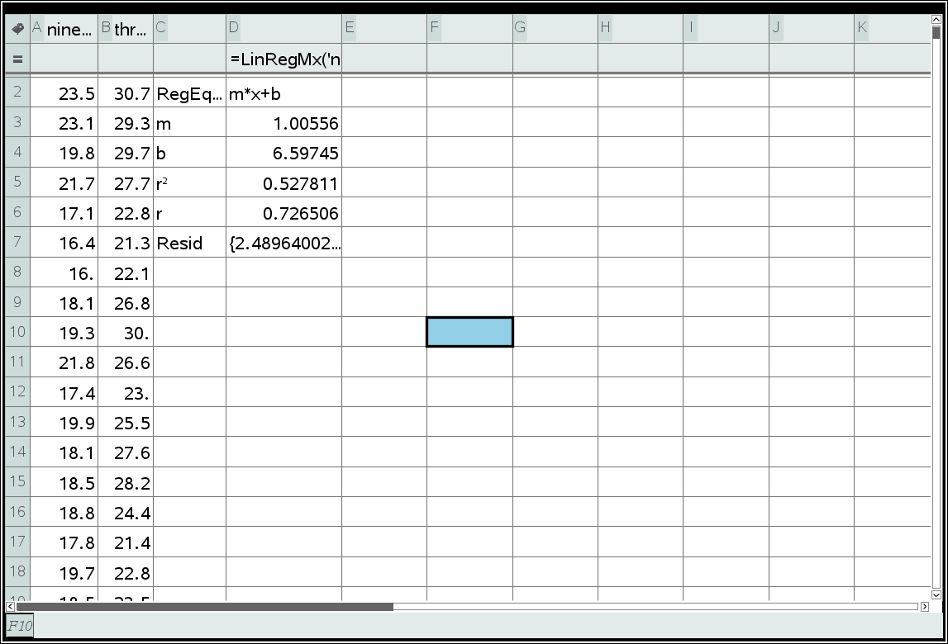 | 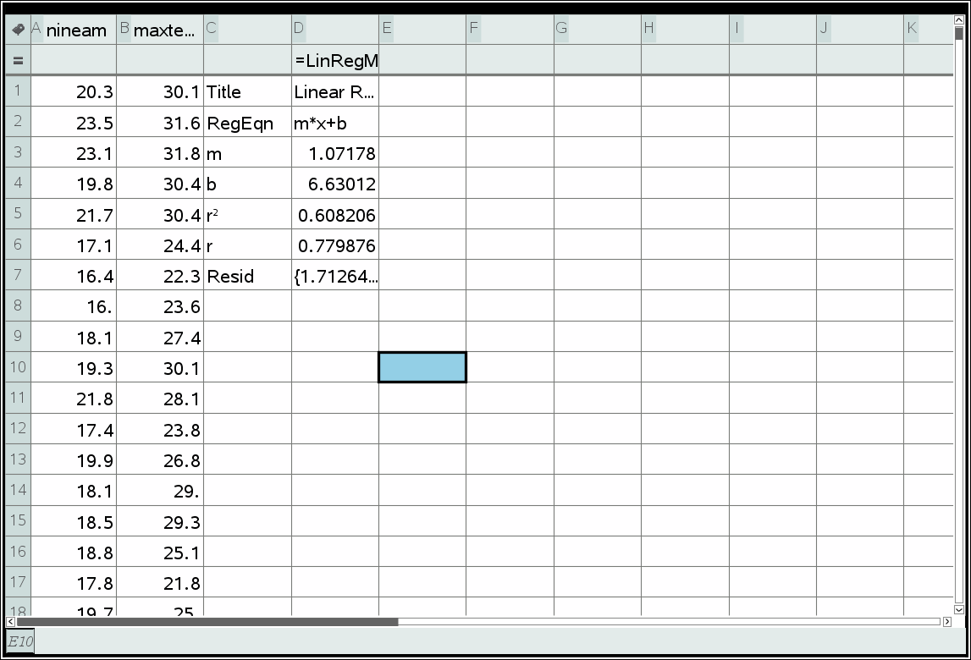

Use your information to answer these questions
If the temperature at 9 am is 21.1º
- predict the temperature at 3 pm and the Max temperature

3pm : 27.81 º
Max: 29.24 º
- comment on the reliability of both predictions
Reasonable reliable moderate positive linear relationship - Interpolation
Nine and max has a higher correlation, more reliable
If the temperature at 9 am is 25 º
- predict the temperature at 3 pm and the Max temperature
3pm : 31.74 º
Max: 33.42 º
- comment on the reliability of both predictions

Extrapolation – Therefore unreliable
- What is the formula to calculate the residuals of the each predication?
Residual = actual y value – predicted y value

Calculate the residuals for the Temperature at 9am and 3am and sketch a graph of them.
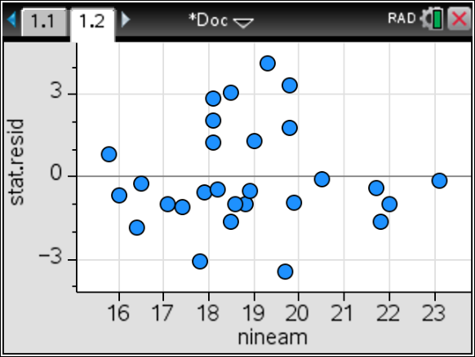
Use the residual plot to decide if the data being investigated is linear or non-linear

A linear model is appropriate here are there is no pattern in the residuals

- Does a Higher temperature mean cause increased Evaporation?

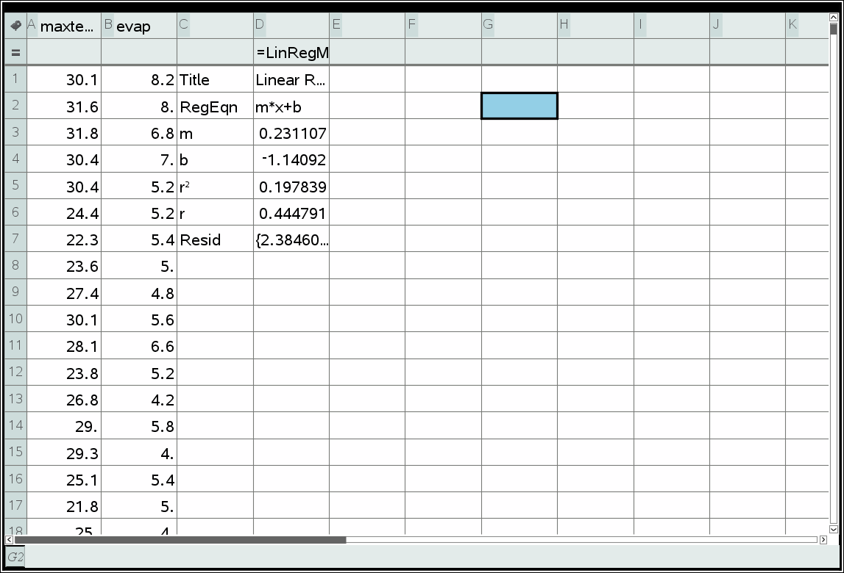
No low correlation and even if there was correlation does not mean causation
In Class Validation Answers
From the April 2017 weather data consider the Date and the Max Temperature data
- Identify the response variable and the explanatory variable

Response ___________________________

Explanatory___________________________
Solution
Response is Max Temperature
Explanatory is Date
Specific Behaviours
Identifies correct Variables

- What is the correlation coefficient and equation of the line of regression for this relationship to 2 decimal places?
Solution
r = -0.36

y= -0.11x+28.74
Specific Behaviours
determines the correlation coefficient
determines the line of regression

- Predict the temperature on April 31st using the equation

Solution
25.33
Specific Behaviours
Correctly predicts the temperature

- Comment on its reliability

Solution
Not reliable - extrapolation
low correlation
Specific Behaviours
Correctly states the reliabilty and states valid reason why

Question 2

